# IBM DS4K SAN Storage and Storage Manger

**IBM DS Manager V10 Client software** needed to be installed and configured to manage IBM DS4300

Controllers:

|  |  |  |  |
| --- | --- | --- | --- |
| Products | User ID | PASSWORD | IP Address |
| SAN Controller A | N/A | passwd | 192.168.103.214 |
| SAN Controller B |  |  | 192.168.103.215 |

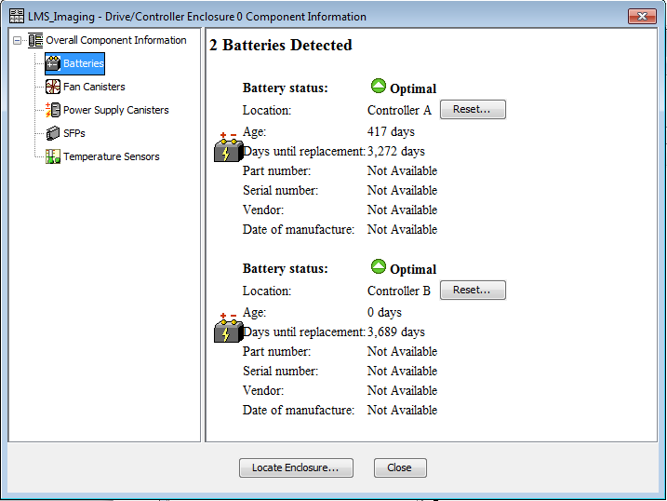

EXP810 in rack Q30; Product ID: 1722-600;

|  |  |
| --- | --- |
| ~~Part number:~~ | ~~PN 25R0222~~ |
| ~~Serial number:~~ | ~~SN 13H2145~~ |
| ~~Vendor:~~ | ~~VN IBM~~ |
| ~~Date of manufacture:~~ | ~~November 1, 2005~~ |

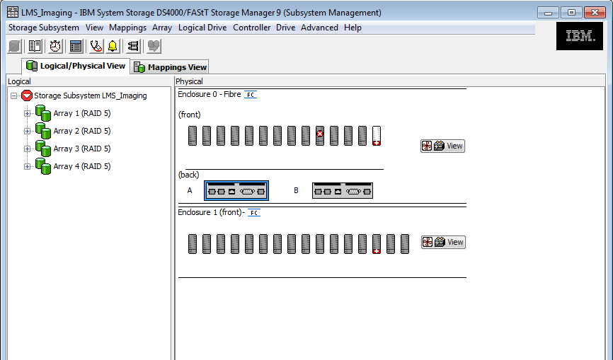

(In this picture, one hard disk failed, and one hot spare disk in-use)

Array: A set of hard disks that the controller logically groups together with Redundrncy level(0,1,10,3,5) to provide logic drives, in our environment, we create RAID-5 Array(1,2,3,4), later, I added additional hard disks to existed arrays,

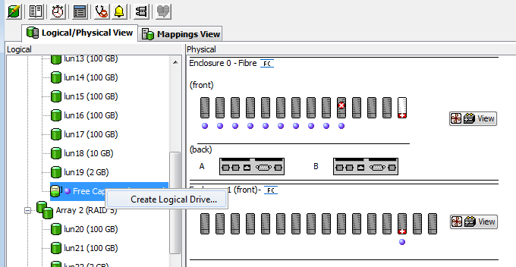

Create Logic Drive(s) on Free Array Capacity, choose different Preferred Controller(owner of this logic drive) for each Logic Drive for load balance consideration.

A storage partition () is a logical entity consisting of one or more storage subsystem logical drives that can be shared among hosts, which might be part of a hosts group or accessed by a single host. A storage partition is created when you define a collection of hosts (a hosts group) or a single host and then define a logic-drive-to-lun-mapping. This mapping allows you to define what host group or host will have access to a particular logical drive in your storage subsystem.

TOPOLOGY DEFINITIONS

|  |  |  |  |
| --- | --- | --- | --- |
| Host Group | Host | HBA Host Ports | Network address |
| Adminserv_Imaging | machineA | fcs0 | 10000000C944AD84 |
|  |  | fcs1 | 10000000C944B3B5 |
|  | machineB | fcs0 | 10000000C944B5EE |
|  |  | fcs1 | 10000000C944B467 |

TIPS: Storage systems know only WWNs of HBAs on OS, know nothing(or don’t care about) any WWNs of Switch ports and/or other storage controllers/Tape Library controllers/Tape Drivers

1. Create each logical drive according to the procedures in Creating a Logical Drive. When entering logical drive-to-LUN mapping settings, use the recommended settings or select Map later with Storage Partitioning.
2. Define the Host Group (Adminserv_Imaging) according to the procedures in Defining a Host Group. You must create host groups because multiple hosts must have access to the same logical drives.
3. Define the hosts (machina A and B) under the host groups according to the procedures in Defining a Host.
4. Define the (Machina A fsc0, fsc1 and Machine B fsc0, fsc1) according to the procedures in Defining an HBA Host Port. The host bus adapter (HBA) host ports are the topological entity that enables the hosts to access the logical drives.
5. Assign access for each host group or host according to the procedures in Using the Storage Partitioning Wizard. For example, select Host, and define an exclusive logical drive-to-LUN mapping for Logical Drive. Then, select Host Group, and define logical drive-to-LUN mappings for Logical Drives.

Mapping Views: 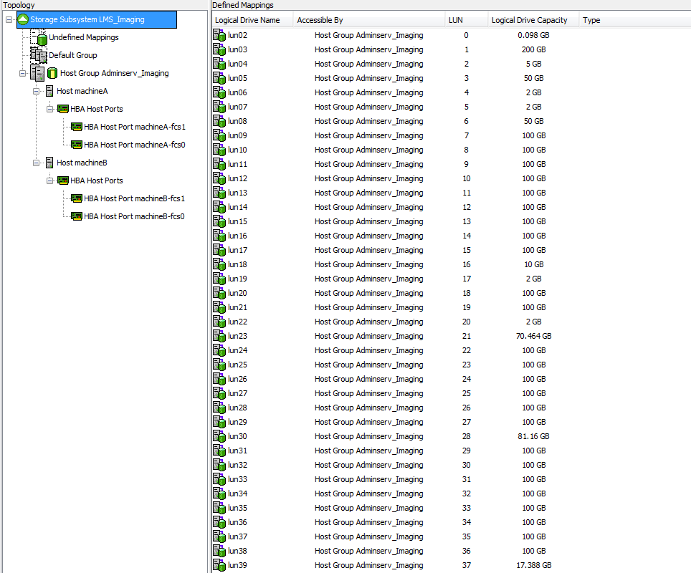

DEFAULT GROUP

Default type: AIX

HOST GROUP Adminserv_Imaging

Host: machineA

Host Port: 10:00:00:00:c9:44:b3:b5

Alias: machineA-fcs1

Type: AIX

Host Port: 10:00:00:00:c9:44:ad:84

Alias: machineA-fcs0

Type: AIX

Host: machineB

Host Port: 10:00:00:00:c9:44:b4:67

Alias: machineB-fcs1

Type: AIX

Host Port: 10:00:00:00:c9:44:b5:ee

Alias: machineB-fcs0

Type: AIX

LUN to Host Group MAPPINGS (Storage Partitioning - Enabled (1 of 8 used))

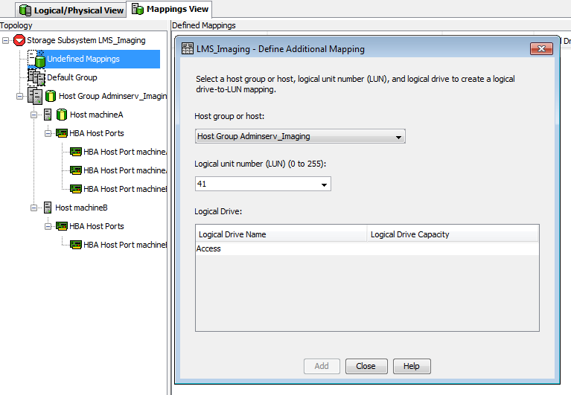

Define Logic Drive to Host Group or Hosts

1. From the Topology pane of the Mapping View , select the Default Group, Undefined Mappings node, an individual undefined mapping, a host group, or a host. Then, select Mappings >> Define >> Additional Mapping.
2. Select a host group Adminserv_Imaging (or host) to which the logical drive is to be mapped from the Host group or host drop-down list.

All defined hosts, host groups, and the Default Group are displayed as options.

Note: If a host or host group is selected that does not have a Host bus adapter(HBA) defined, a warning dialog is displayed.

1. Select a single LUN (0 through 254) from the drop-down list.

Note: Only available LUNs are displayed, Some OS(Solaris,HP-UX) cannot access LUN number larger than 32

1. Select the logical drive to be mapped to from the Logical Drive table. The table lists the names and capacity of the logical drives that are available for mapping, based on the host group or host selected.

Note: You can include a Remote Mirror secondary logical drive??in a partition. However, any hosts that are mapped to this logical drive will have read-only access to it until it is promoted to a Remote Mirror primary logic drive or until the mirror relationship is removed.

1. Select Add to save the logical drive-to-LUN mapping, and leave the dialog open.

Note: The Add button remains unavailable until a host group, host, LUN, and logical drive are selected.

1. Repeat steps 2 through 5 to add multiple additional logical drives to the storage partition.

Note: Once a logical drive has been mapped once, it is no longer available in the Logical Drive table.

1. Select Close to exit the dialog.

The logical drive-to-LUN mappings are saved. The Topology and Defined Mappings panes in the Mappings View are updated to reflect the additional mappings.

VOLUME NAME LUN CONTROLLER ACCESSIBLE BY VOLUME STATUS

lun02 0 A Host Group Adminserv_Imaging Optimal

lun03 1 B Host Group Adminserv_Imaging Optimal

lun04 2 A Host Group Adminserv_Imaging Optimal

lun05 3 B Host Group Adminserv_Imaging Optimal

lun06 4 A Host Group Adminserv_Imaging Optimal

lun07 5 B Host Group Adminserv_Imaging Optimal

lun08 6 A Host Group Adminserv_Imaging Optimal

lun09 7 B Host Group Adminserv_Imaging Optimal

lun10 8 A Host Group Adminserv_Imaging Optimal

lun11 9 B Host Group Adminserv_Imaging Optimal

lun12 10 A Host Group Adminserv_Imaging Optimal

lun13 11 B Host Group Adminserv_Imaging Optimal

lun14 12 A Host Group Adminserv_Imaging Optimal

lun15 13 B Host Group Adminserv_Imaging Optimal

lun16 14 A Host Group Adminserv_Imaging Optimal

lun17 15 B Host Group Adminserv_Imaging Optimal

lun18 16 A Host Group Adminserv_Imaging Optimal

lun19 17 B Host Group Adminserv_Imaging Optimal

lun20 18 A Host Group Adminserv_Imaging Optimal

lun21 19 B Host Group Adminserv_Imaging Optimal

lun22 20 A Host Group Adminserv_Imaging Optimal

lun23 21 B Host Group Adminserv_Imaging Optimal

lun24 22 A Host Group Adminserv_Imaging Optimal

lun25 23 B Host Group Adminserv_Imaging Optimal

lun26 24 A Host Group Adminserv_Imaging Optimal

lun27 25 B Host Group Adminserv_Imaging Optimal

lun28 26 A Host Group Adminserv_Imaging Optimal

lun29 27 B Host Group Adminserv_Imaging Optimal

lun30 28 A Host Group Adminserv_Imaging Optimal

lun31 29 B Host Group Adminserv_Imaging Optimal

lun32 30 A Host Group Adminserv_Imaging Optimal

lun33 31 B Host Group Adminserv_Imaging Optimal

lun34 32 A Host Group Adminserv_Imaging Optimal

lun35 33 B Host Group Adminserv_Imaging Optimal

lun36 34 A Host Group Adminserv_Imaging Optimal

lun37 35 B Host Group Adminserv_Imaging Optimal

lun38 36 A Host Group Adminserv_Imaging Optimal

lun39 37 B Host Group Adminserv_Imaging Optimal

root@admsrv1:/ # mpio_get_config -Av

Warning: Unable to open message catalog.

Frame id 0:

Storage Subsystem worldwide name: 60ab80019887600004371bb43

Controller count: 2

Partition count: 1

Partition 0:

Storage Subsystem Name = 'LMS_Imaging'

hdisk# LUN # Ownership User Label

hdisk2 0 A (preferred) lun02

hdisk3 1 B (preferred) lun03

hdisk4 2 A (preferred) lun04

hdisk5 3 B (preferred) lun05

hdisk6 4 A (preferred) lun06

hdisk7 5 B (preferred) lun07

hdisk8 6 A (preferred) lun08

hdisk9 7 B (preferred) lun09

hdisk10 8 A (preferred) lun10

hdisk11 9 B (preferred) lun11

hdisk12 10 A (preferred) lun12

hdisk13 11 B (preferred) lun13

hdisk14 12 A (preferred) lun14

hdisk15 13 B (preferred) lun15

hdisk16 14 A (preferred) lun16

hdisk17 15 B (preferred) lun17

hdisk18 16 A (preferred) lun18

hdisk19 17 B (preferred) lun19

hdisk20 18 A (preferred) lun20

hdisk21 19 B (preferred) lun21

hdisk22 20 A (preferred) lun22

hdisk23 21 B (preferred) lun23

hdisk24 22 A (preferred) lun24

hdisk25 23 B (preferred) lun25

hdisk26 24 A (preferred) lun26

hdisk27 25 B (preferred) lun27

hdisk28 26 A (preferred) lun28

hdisk29 27 B (preferred) lun29

hdisk30 28 A (preferred) lun30

hdisk31 29 B (preferred) lun31

hdisk32 30 A (preferred) lun32

hdisk33 31 B (preferred) lun33

hdisk34 32 A (preferred) lun34

hdisk35 33 B (preferred) lun35

hdisk36 34 A (preferred) lun36

hdisk37 35 B (preferred) lun37

hdisk38 36 A (preferred) lun38

hdisk39 37 B (preferred) lun39

root@admsrv2# mpio_get_config -Av

Warning: Unable to open message catalog.

Frame id 0:

Storage Subsystem worldwide name: 60ab80019887600004371bb43

Controller count: 2

Partition count: 1

Partition 0:

Storage Subsystem Name = 'LMS_Imaging'

hdisk# LUN # Ownership User Label

hdisk2 0 A (preferred) lun02

hdisk3 1 B (preferred) lun03

hdisk4 2 A (preferred) lun04

hdisk5 3 B (preferred) lun05

hdisk6 4 A (preferred) lun06

hdisk7 5 B (preferred) lun07

hdisk8 6 A (preferred) lun08

hdisk9 7 B (preferred) lun09

hdisk10 8 A (preferred) lun10

hdisk11 9 B (preferred) lun11

hdisk12 10 A (preferred) lun12

hdisk13 11 B (preferred) lun13

hdisk14 12 A (preferred) lun14

hdisk15 13 B (preferred) lun15

hdisk16 14 A (preferred) lun16

hdisk17 15 B (preferred) lun17

hdisk18 16 A (preferred) lun18

hdisk19 17 B (preferred) lun19

hdisk20 18 A (preferred) lun20

hdisk21 19 B (preferred) lun21

hdisk22 20 A (preferred) lun22

hdisk23 21 B (preferred) lun23

hdisk24 22 A (preferred) lun24

hdisk25 23 B (preferred) lun25

hdisk26 24 A (preferred) lun26

hdisk27 25 B (preferred) lun27

hdisk28 26 A (preferred) lun28

hdisk29 27 B (preferred) lun29

hdisk30 28 A (preferred) lun30

hdisk31 29 B (preferred) lun31

hdisk32 30 A (preferred) lun32

hdisk33 31 B (preferred) lun33

hdisk34 32 A (preferred) lun34

hdisk35 33 B (preferred) lun35

hdisk36 34 A (preferred) lun36

hdisk37 35 B (preferred) lun37

hdisk38 36 A (preferred) lun38

hdisk39 37 B (preferred) lun39

